**Creating calculated columns**

In this demo, you create data in your model by adding calculated columns. You can create calculated columns (as custom columns) when using Get Data, by using the Query Editor, or later in the model designer like you do here.

You create five new calculated columns in three different tables. The steps are slightly different for each task showing there are several ways to create columns, rename them, and place them in various locations in a table.

This demo is also where you first use Data Analysis Expressions (DAX). DAX is a special language for creating highly customizable formula expressions for tabular models. In this tutorial, you use DAX to create calculated columns, measures, and role filters.

## **Creating calculated columns**

#### Create a MonthCalendar calculated column in the DimDate table

1. Click the **Model** menu > **Model View** > **Data View**.

Calculated columns can only be created by using the model designer in Data View.

1. In the model designer, click the **DimDate** table (tab).
2. Right-click the **CalendarQuarter** column header, and then click **Insert Column**.

A new column named **Calculated Column 1** is inserted to the left of the **Calendar Quarter** column.

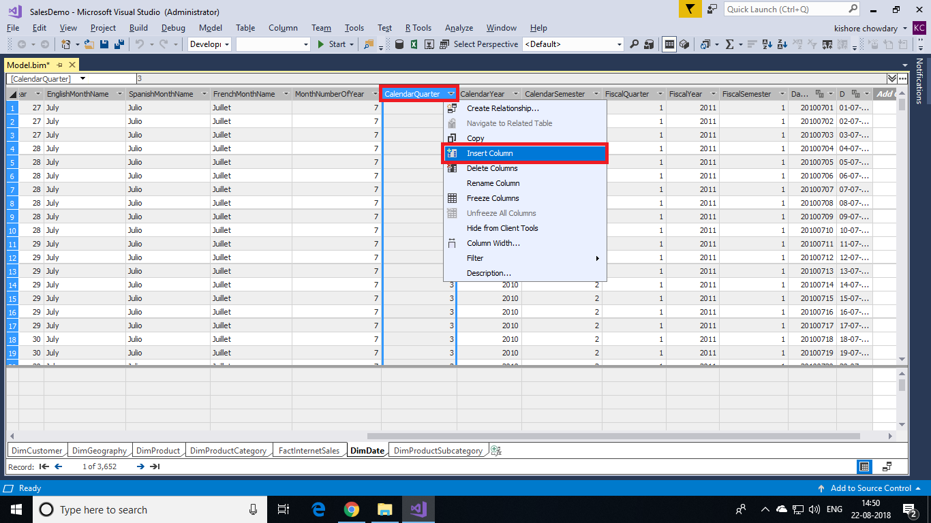

1. In the formula bar above the table, type the following DAX formula: AutoComplete helps you type the fully qualified names of columns and tables, and lists the functions that are available.

=RIGHT(" " & FORMAT([MonthNumberOfYear],"#0"), 2) & " - " & [EnglishMonthName]

Values are then populated for all the rows in the calculated column. If you scroll down through the table, you see rows can have different values for this column, based on the data in each row.

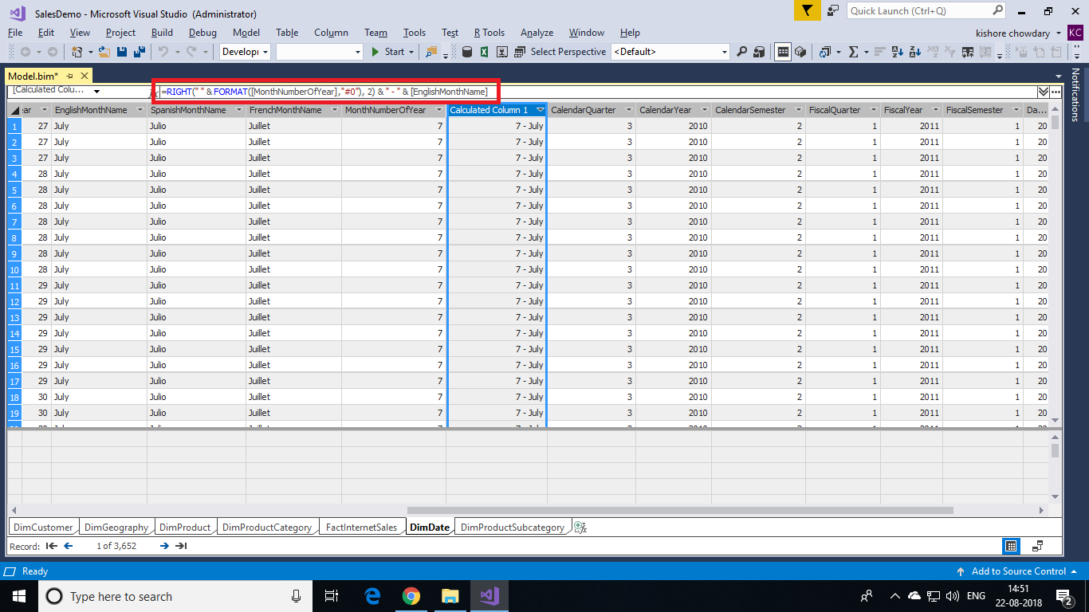

1. Rename this column to **MonthCalendar**.

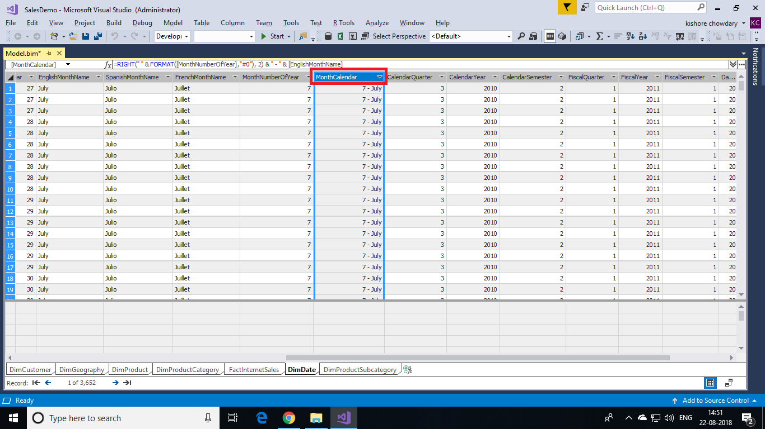

The MonthCalendar calculated column provides a sortable name for Month.

#### **Creating a DayOfWeek calculated column in the DimDate table**

1. With the **DimDate** table still active, click the **Column** menu, and then click **Add Column**.

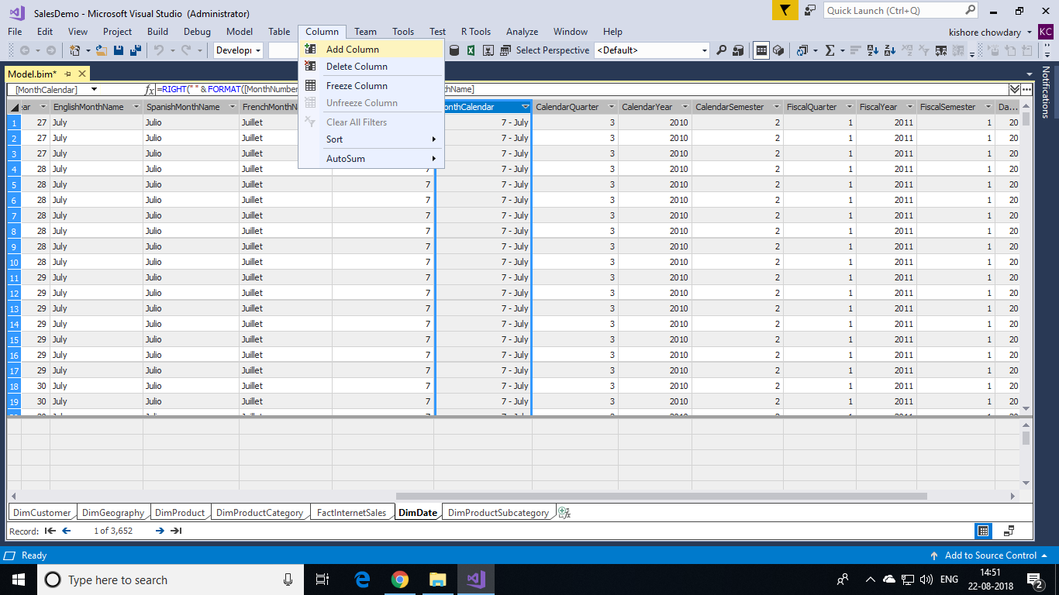

1. In the formula bar, type the following formula:

=RIGHT(" " & FORMAT([DayNumberOfWeek],"#0"), 2) & " - " & [EnglishDayNameOfWeek]

When you've finished building the formula, press ENTER. The new column is added to the far right of the table.

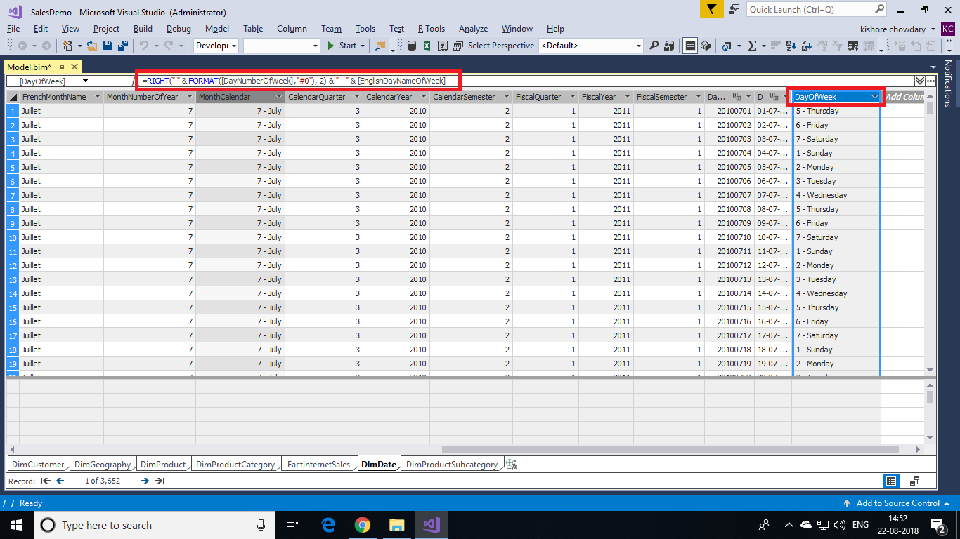

1. Rename the column to **DayOfWeek**.
2. Click the column heading, and then drag the column between the **EnglishDayNameOfWeek** column and the **DayNumberOfMonth** column. The DayOfWeek calculated column provides a sortable name for the day of week.

#### **Creating a ProductSubcategoryName calculated column in the DimProduct table**

1. In the **DimProduct** table, scroll to the far right of the table. Notice the right-most column is named **Add Column** (italicized), click the column heading.
2. In the formula bar, type the following formula:

=RELATED('DimProductSubcategory'[EnglishProductSubcategoryName])

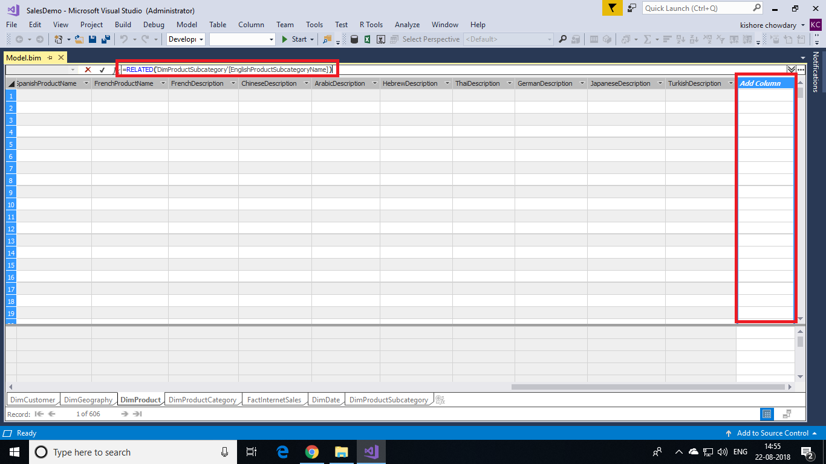

1. Rename the column to **ProductSubcategoryName**.

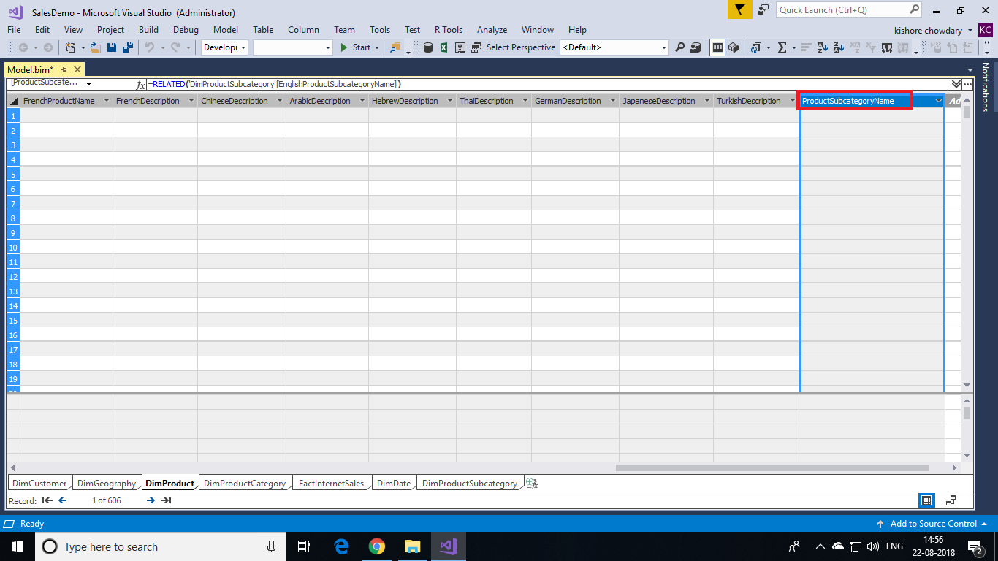

The ProductSubcategoryName calculated column is used to create a hierarchy in the DimProduct table, which includes data from the EnglishProductSubcategoryName column in the DimProductSubcategory table.

#### **Create a ProductCategoryName calculated column in the DimProduct table**

1. With the **DimProduct** table still active, click the **Column** menu, and then click **Add Column**.
2. In the formula bar, type the following formula:

=RELATED('DimProductCategory'[EnglishProductCategoryName])

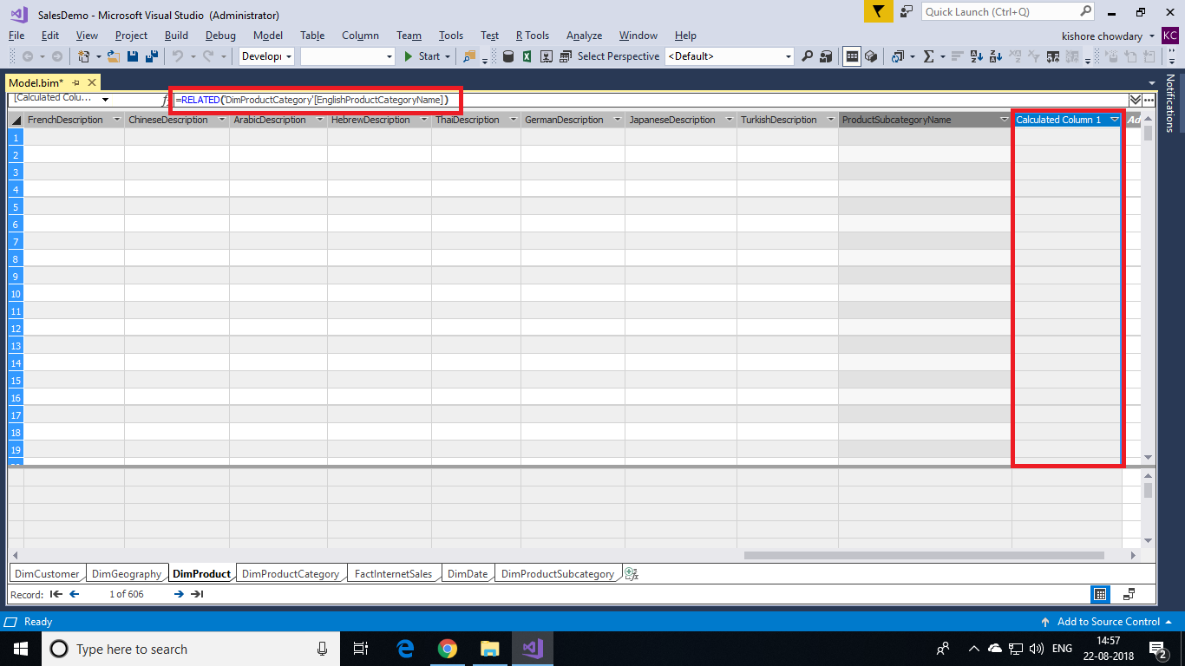

1. Rename the column to **ProductCategoryName**.

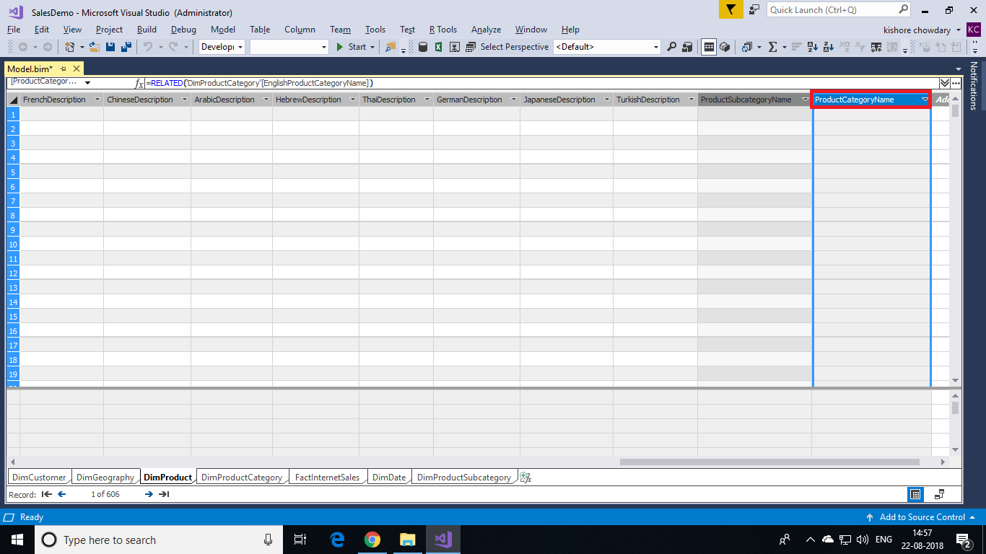

The ProductCategoryName calculated column is used to create a hierarchy in the DimProduct table, which includes data from the EnglishProductCategoryName column in the DimProductCategory table.

#### **Create a Margin calculated column in the FactInternetSales table**

1. In the model designer, select the **FactInternetSales** table.
2. Create a new calculated column between the **SalesAmount** column and the **TaxAmt** column.

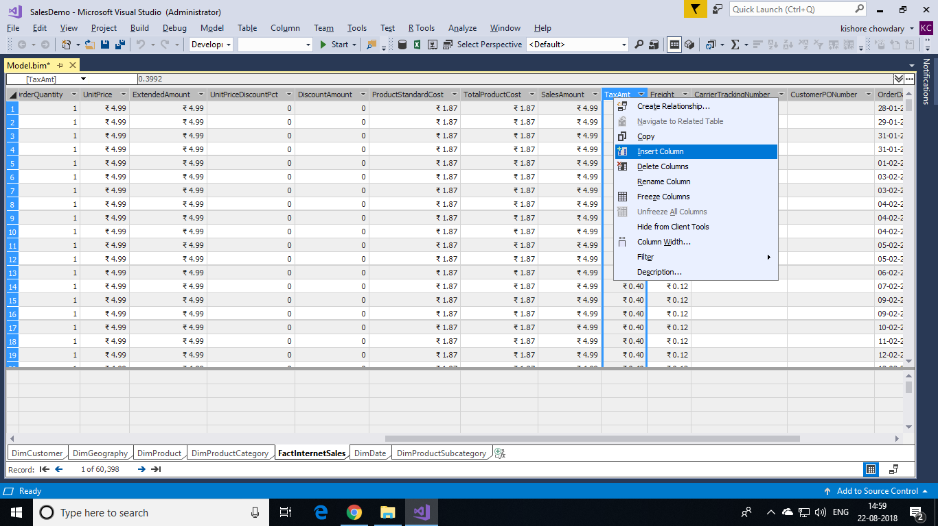

1. In the formula bar, type the following formula:

=[SalesAmount]-[TotalProductCost]

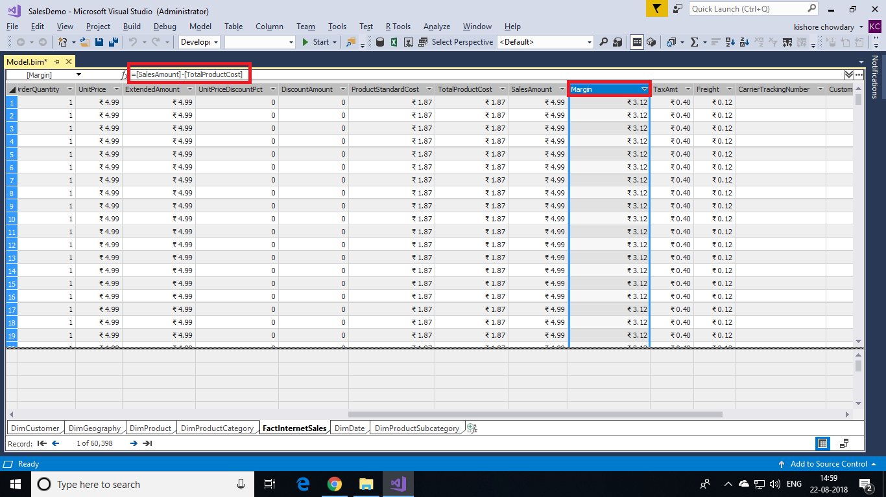

1. Rename the column to **Margin**. The Margin calculated column is used to analyse profit margins for each sale.